Graph Theory Fall 2020

Assignment 5

Due at 5:00 pm on Monday, October 12

1. **The dodecahedron graph is depicted below:**

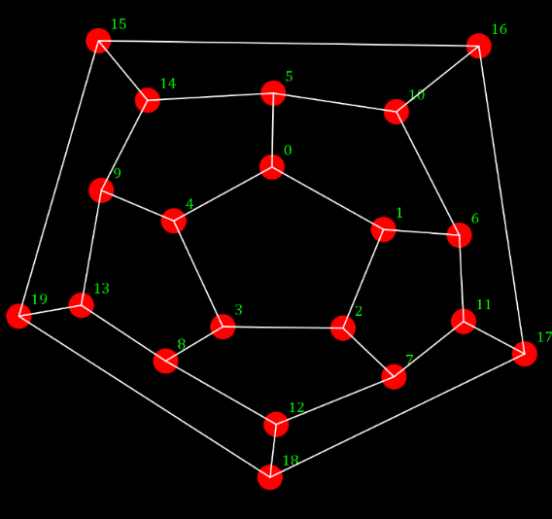

1. **Determine, with justification, whether is Eulerian.**

To determine whether G is Eulerian, we will check the definition of Eulerian. A graph is considered Eulerian if the graph is connected and has a closed trail containing all edges of the graph. The degree of each vertex should be even too. In graph G, the given graph degree of vertices is 3. (ODD number). Therefore, we can deduce that graph G is not Eulerian.

1. **Show that is Hamiltonian by finding a Hamilton cycle.**

A graph is Hamiltonian if there exists a closed walk in the connected graph that visits each vertex of the graph ONLY once without repeating any edge. The given graph G IS Hamiltonian as it contains a Hamiltonian cycle as shown below.

1. 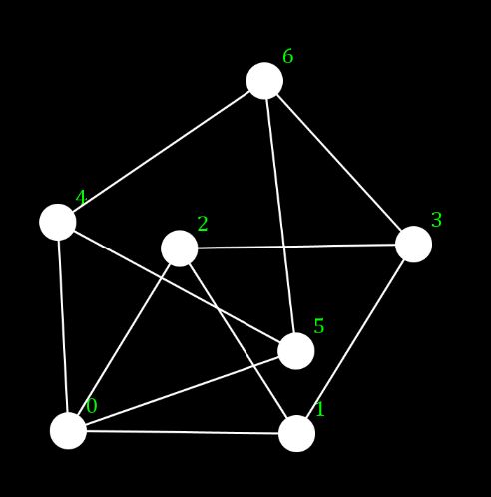**Let be the graph depicted to the right:**
2. **Find a 4-coloring of .**

A 4-coloring of graph H is obtained such that 4 colors are used, and no adjacent vertices have the same colors. 4 colors are: Black, Blue, Green, Yellow. Figure is shown below.

1. **Show that no 3-coloring of exists.**

A 3-coloring of the graph H is obtained such that 3 colors are used, and no two adjacent vertices have the same colors.

1. **The graph is depicted below. Show that this graph is not Hamiltonian. One approach: Show that any Hamilton path must begin and end at even-numbered vertices. Why does this prevent forming a Hamilton cycle?**

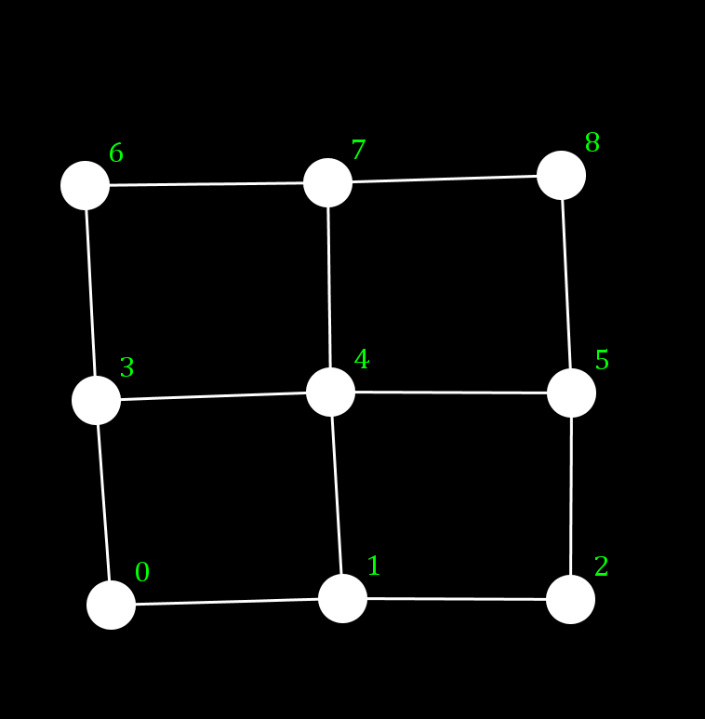

In the graph above, if any graph is to be Hamiltonian, there should exist a closed walk in the connected graph that will be visiting each vertex of the graph without repeating any edges.

In the graph above, one Hamiltonian path will be = 2,1,0,3,4,5,8,7,6 whereas this path is not a closed walk because there is no path from the beginning vertex and ending vertex.

If this graph were to be Hamiltonian (and Hamiltonian cycle), there should be an edge which would connect the beginning and ending vertex and show below:

1. **Find the chromatic polynomial of and determine whether is a factor of .**

Chromatic polynomial is the graph polynomial studied in algebraic graph theory. The chromatic polynomial of a cycle graph is given as ,

We will take n=6, and thus our equation will be as,

Thus, we can concur that (k-2) is not a factor of the final equation above. Therefore, we can say that (k-2) is not a factor of **.**